**Assignment - 50 Linux Commands**

**1: ls**

The most frequently used command in Linux to list directories



**2: cd**

Linux command to navigate through directories



**3: mkdir**

Command used to create directories in Linux



**4: ls -l**

To get detailed list of the directory content

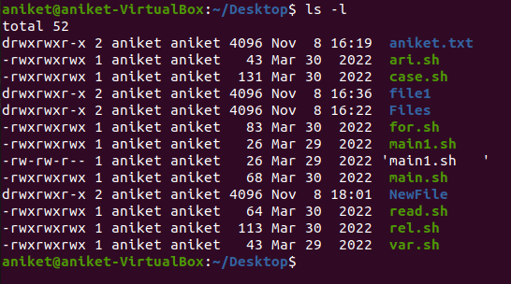

**5: ls -a**

To get the list Off all files/dir including hidden object.



**6: pwd**

Print working directory command in Linux



**7: touch**

Create blank/empty files



**8: cat**

Display file contents on the terminal



**9: whoami**

Get the active username



**10: hostnamectl:**

To check the current host names. (/etc/hostnames)

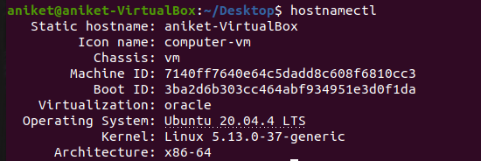

**11: cal**

To show the calendar

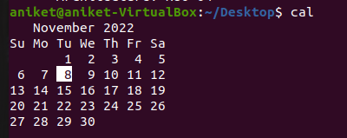

**12: rm**

Delete files or directories



**13: vi**

It is used to create file with contents.

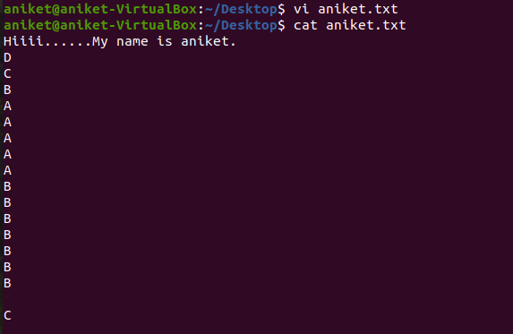

**14: cp**

Similar usage as mv but for copying files in Linux

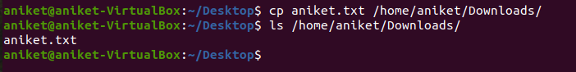

**15: mv**

Move or rename files in Linux

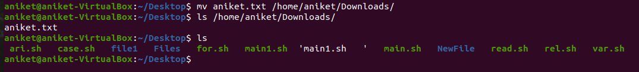

**16: sudo su**

It is used to shift to super user or root user

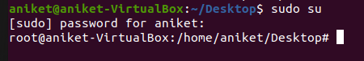

**17: clear**

It is used to clear the terminal.



**18: ln**

Create symbolic links (shortcuts) to other files

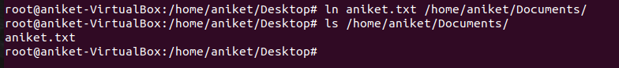

**19: echo**

Print any text that follows the command



**20: df**

Display disk filesystem information

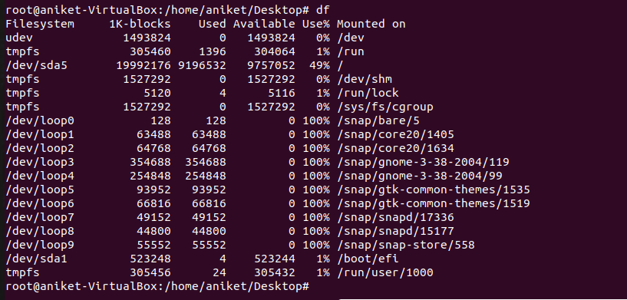

**21: top**

View active processes live with their system usage

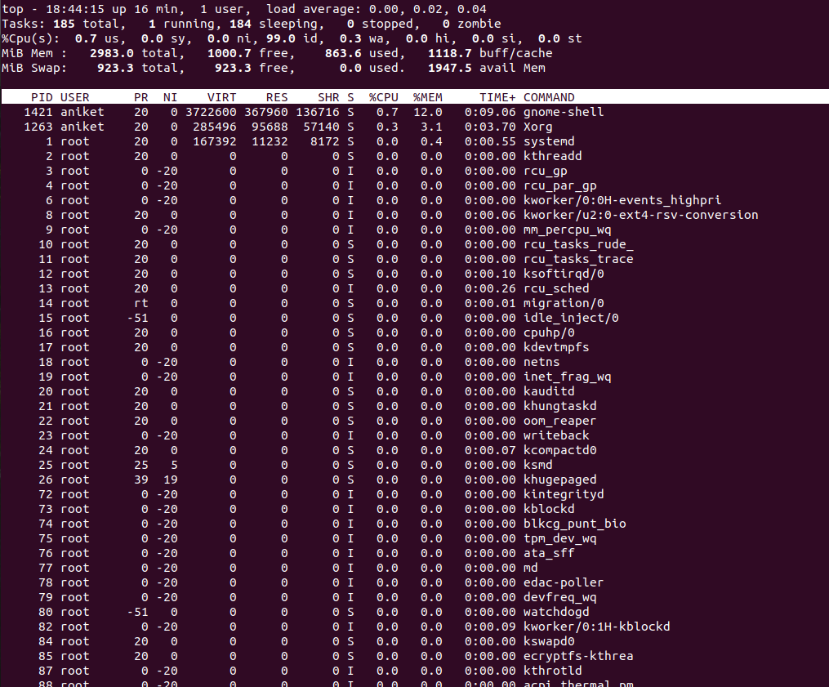

**22: uname -a**

Displays the operating system name as well as the system node name, operating system release, operating system version, hardware name, and processor type.



**23: tar -cvf**

Command to compress files in Linux



**24: tar -xvf**

Command to extract files in Linux

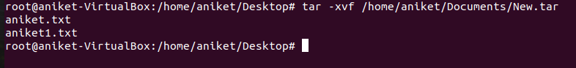

**25: zip**

Zip files in Linux



**26: unzip**

Unzip files in Linux

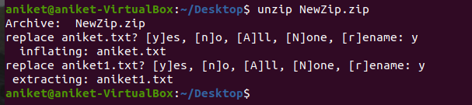

**27: mv**

It is used to rename the file.



**28: grep**

If you wish to search for a specific string within an output, the grep command comes into the picture. We can pipe (**|**) the output to the grep command and extract the required string.



**29: unzip**

Unzip files in Linux



**30: mv**

It is used to rename the file.



**31: grep**

If you wish to search for a specific string within an output, the grep command comes into the picture. We can pipe (**|**) the output to the grep command and extract the required string.



**32: rmdir**

The [rmdir](https://www.javatpoint.com/linux-rmdir) command is used to delete a directory.



**33: cat >**

The [cat](https://www.javatpoint.com/linux-cat) command is a multi-purpose utility in the Linux system. It can be used to create a file, display the content of the file, copy the content of one file to another file, and more.

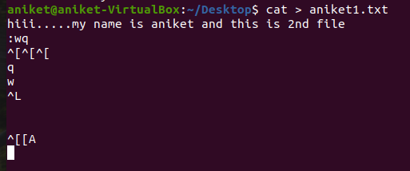

**34: head**

The [head](https://www.javatpoint.com/linux-head) command is used to display the content of a file. It displays the first 10 lines of a file.



**35: tail**

The [tail](https://www.javatpoint.com/linux-tail) command is similar to the head command. The difference between both commands is that it displays the last ten lines of the file content. It is useful for reading the error message.

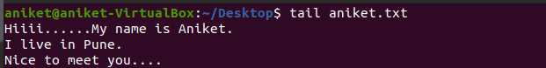



**36: tac**

The [tac](https://www.javatpoint.com/linux-tac) command is the reverse of cat command, as its name specified. It displays the file content in reverse order (from the last line).

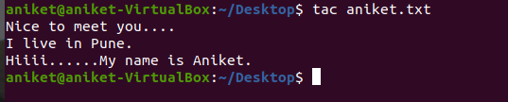

**37: more**

The [more](https://www.javatpoint.com/linux-more) command is quite similar to the cat command, as it is used to display the file content in the same way that the cat command does. The only difference between both commands is that, in case of larger files, more command displays screenful output at a time.

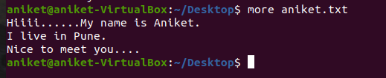

**38: less**

The [less](https://www.javatpoint.com/linux-less) command is similar to the more command. It also includes some extra features such as 'adjustment in width and height of the terminal.' Comparatively, the more command cuts the output in the width of the terminal.

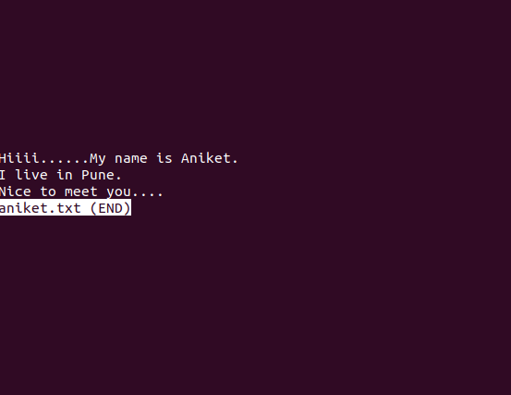

**39: su**

The [su](https://www.javatpoint.com/linux-su-commands) command provides administrative access to another user. In other words, it allows access of the Linux shell to another user.



**40: id**

The [id](https://www.javatpoint.com/linux-id-command) command is used to display the user ID (UID) and group ID (GID).



**41: rename**

The [rename](https://www.javatpoint.com/linux-rename) command is used to rename files. It is useful for renaming a large group of files.

**42: groupadd**

The [groupadd](https://www.javatpoint.com/linux-add-user-to-group) command is used to create a user group.

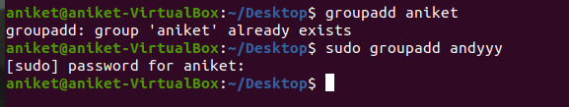

**43: passwd**

The [passwd](https://www.javatpoint.com/linux-user-password) command is used to create and change the password for a user.

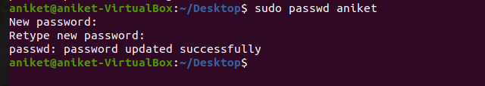

**44: cut**

The [cut](https://www.javatpoint.com/linux-cut) command is used to select a specific column of a file. The '-d' option is used as a delimiter, and it can be a space (' '), a slash (/), a hyphen (-), or anything else. And, the '-f' option is used to specify a column number.

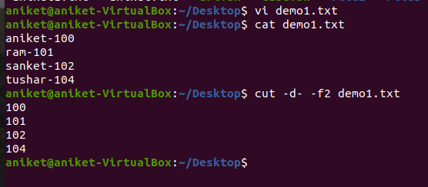

**45: comm**

The ['comm'](https://www.javatpoint.com/linux-comm) command is used to compare two files or streams. By default, it displays three columns, first displays non-matching items of the first file, second indicates the non-matching item of the second file, and the third column displays the matching items of both files.

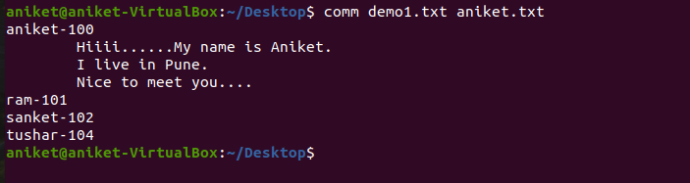

**46: sed**

The [sed](https://www.javatpoint.com/linux-sed) command is also known as **stream editor**. It is used to edit files using a regular expression. It does not permanently edit files; instead, the edited content remains only on display. It does not affect the actual file.

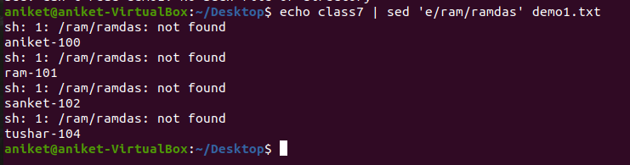

**47: tee**

The [tee](https://www.javatpoint.com/linux-tee) command is quite similar to the cat command. The only difference between both filters is that it puts standard input on standard output and also write them into a file.

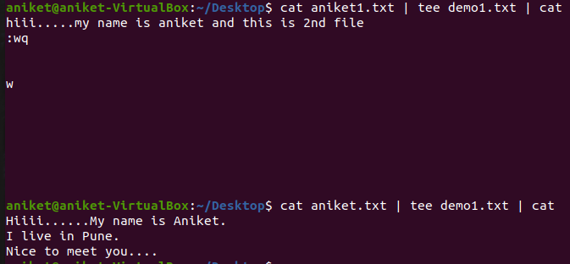

**48: tr**

The [tr](https://www.javatpoint.com/linux-tr) command is used to translate the file content like from lower case to upper case.

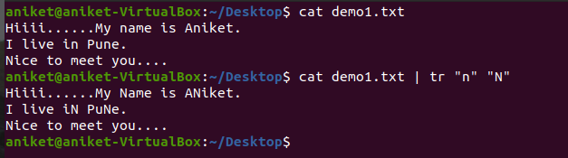

**49: uniq**

The [uniq](https://www.javatpoint.com/linux-uniq) command is used to form a sorted list in which every word will occur only once.

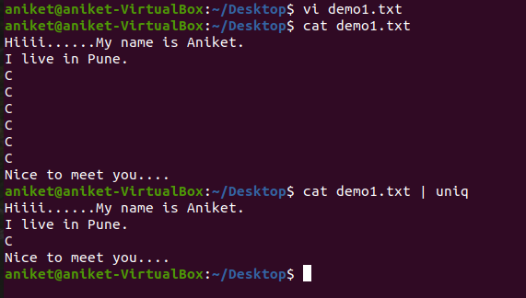

**50: wc**

The [wc](https://www.javatpoint.com/linux-wc) command is used to count the lines, words, and characters in a file.

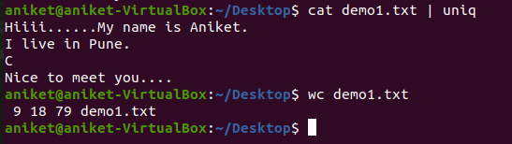

**51: od**

The [od](https://www.javatpoint.com/linux-od) command is used to display the content of a file in different s, such as hexadecimal, octal, and ASCII characters.

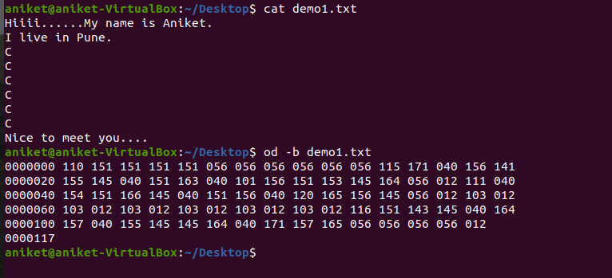

**52: sort**

The [sort](https://www.javatpoint.com/linux-sort) command is used to sort files in alphabetical order.

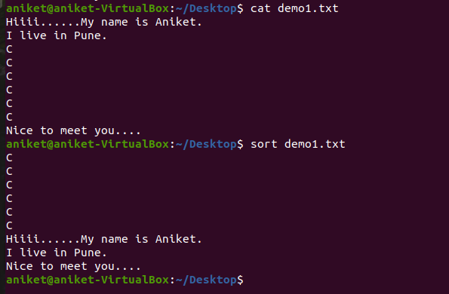

**53: gzip**

The [gzip](https://www.javatpoint.com/linux-gzip) command is used to truncate the file size. It is a compressing tool. It replaces the original file by the compressed file having '.gz' extension.

